An Overview of Xilinx FPGAs: Features and Comparative Performance

AJITH RAVINDRAN
NSSCE
M.TECH POWER ELECTRONICS
AJITH RAVINDRAN123@YAHOO.COM
l

Introduction (Heading 1)
FPGAs (Field-Programmable Gate Arrays) are versatile microchips that can be configured after manufacturing, offering flexibility for prototyping and adapting to changing needs. Compared to ASICs (Application-Specific Integrated Circuits), FPGAs are faster to develop and have lower upfront costs, making them ideal for low-volume production or situations where the design might change. However, ASICs boast superior performance, lower power consumption, and become cheaper per unit for high-volume production runs. In essence, FPGAs excel in adaptability and fast turnaround times, while ASICs win in optimized performance and cost-effectiveness for mass production.

FEATURES
- Spartan-7 FPGAs: Shine in applications demanding a sweet spot of affordability, low power usage, and strong I/O capabilities. Their compact size makes them ideal for space-constrained designs.
- Artix-7 FPGAs: Offer a balance between optimization and flexibility for low-power devices. They excel in handling high-bandwidth serial peripherals and digital signal processing (DSP) tasks. Notably, Artix-7 stands out for its cost-effective design, minimizing material expenses for manufacturers building high-performance, budget-conscious digital products.
- Kintex-7 FPGAs: Strike a balance between exceptional performance and value. They offer a significant performance boost (around 2x) over their predecessors at a competitive price point, making them ideal for cost-conscious applications demanding high performance.
- V irtex-7 FPGA family: Designed and optimized for the best performance of developed digital devices, with a 2-fold improvement in performance compared to previous generations at a low price.
- FPGAs: Zynq® UltraScale+™ MPSoCs (Multi-Processor System-on-Chip): Integrate an FPGA fabric with ARM processing cores, real-time processors, and high-speed interfaces. Well-suited for embedded systems requiring both Processing power and hardware customization, like industrial control systems and motor control.

Comparative FPGA Performance of the 7th Series of Xilinx
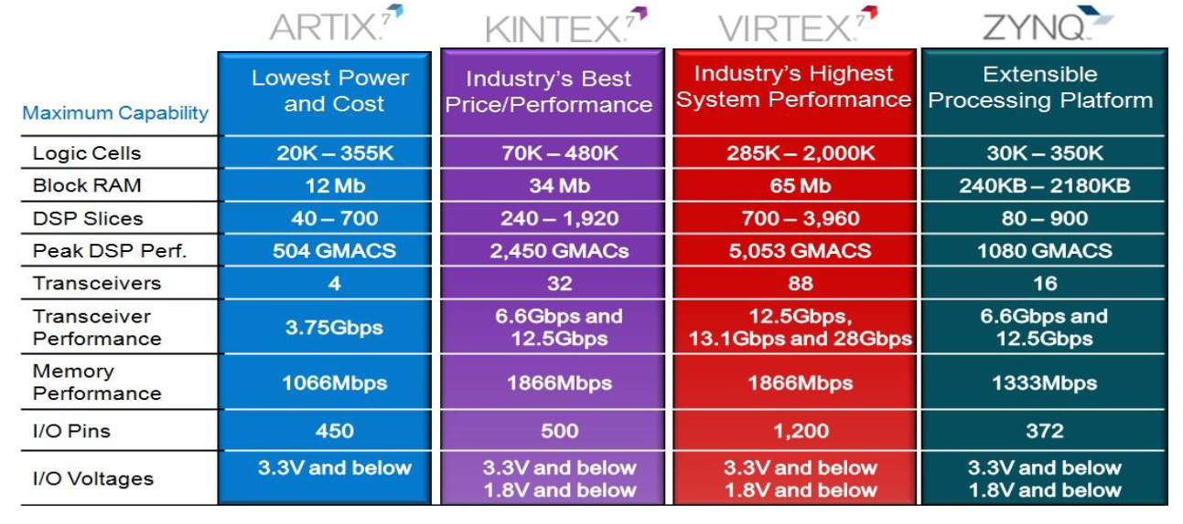

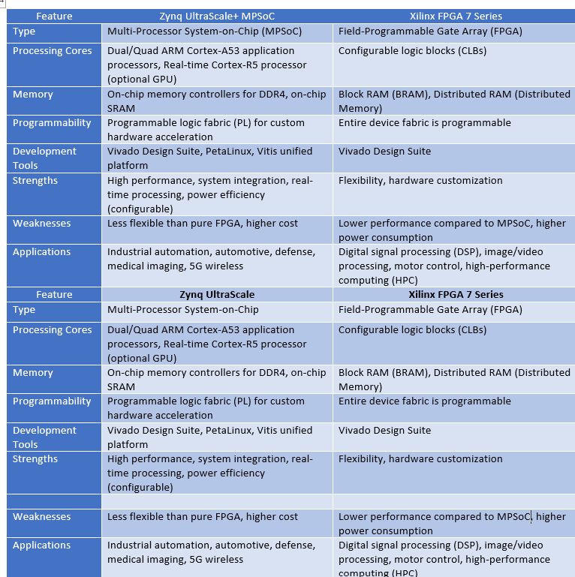
CONCLUSIONS

All Xilinx Series 7 FPGA chips have a common

architecture that is organized in the form of columns of

function blocks of the same type. Such an architecture is

called an optimized silicon modular block. In addition, the

Xilinx stack silicon interconnect technology used on some

Virtex-7 chipsets allows the FPGA architecture to be

introduced at the next structural level, making it possible to

create a very high density and performance FPGA

References
[1]. Spartan-7 FPGAs Data Sheet:DC and AC Switching Characteristics.
Product Specification. DS189 (v1.9) March 13, 2019", Xilinx.com,2019.
[2] 7 Series Product Tables and Product Selection Guide", Xilinx.com,
2019.[Online].

